Advanced Games Programming
Tutorial 08 - Texture Mapping

Introduction

In a 3D game, most of the objects in the 3D world have visibly different surfaces such as brick walls, marble and so on. These surfaces are stored in memory as texture maps, which are essentially images stored in memory. To add a texture to an object you first need to configure the object to use textures by giving it texture coordinates. You then load in the texture from file and apply it to the object using the texture coordinates - this is called texture mapping.

Texture Mapping

Direct3D allow the use of 1D, 2D and 3D textures, however the most used of these is the 2D texture which will be used in this tutorial to demonstrate texture mapping. For simplicity the term texture should be synonymous with 2D texture for this tutorial.

A texture is a rectangular image, made up of square texels, here's a simple 4x4 texture:

Each element of this grid is a texel - for instance the blue square represents one texel.

The texture is referenced by texture coordinates that are defined within an object's vertices. The texture coordinates are represented as two floating point numbers, u and v, one referring to horizontal and one to vertical position in the texture, and are generally in the range of 0.0 to 1.0 (though you can go outside this to achieve certain effects such as tiling). So in any given texture, (0.0, 0.0) would represent the top left, (1.0, 0.0) top right, (1.0, 1.0) the bottom right, (0.5, 0.5) the centre, etc.:
u

(0.0, 0.0)

(1.0, 0.0)

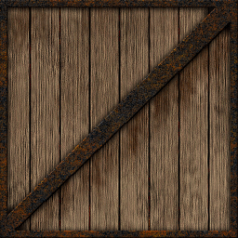
(0.0, 1.0)

(1.0, 1.0)

v

(0.5, 0.5)

You should always try to work with textures that have sides that are a power of 2, e.g. 1, 2, 4, 8, 16, 32, 64, etc., and it's generally best to work with square textures when you can. The reasons for this are that some hardware is not capable of using textures that aren't this size and shape, and secondly a lot of hardware is optimised for this type of texture.

When rendering the object, the texture coordinates are interpolated between the vertices, in exactly the same way that colours are interpolated. Each pixel drawn on the screen will sample the texture using the interpolated coordinate values to find the colour of the texel at that point, which is then used by the pixel shader to generate the final pixel colour . The interpolation ensures that a continuous image is mapped onto the object, so for instance here a triangle's vertices have been mapped like so onto a texture:

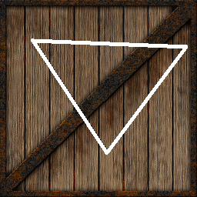
(0.1, 0.15)

(0.95, 0.2)

(0.5, 0.8)

and the result when rendering that triangle would be:
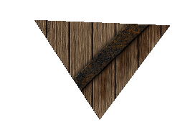

Loading a Texture

Textures in Direct3D are stored in shader resource view objects. Essentially all this means is there is a pointer to an area of memory where some data that is used by shaders is stored, in this case a texture. Direct3D provides a straightforward method of loading textures using the D3DX11CreateShaderResourceViewFromFile() function. This function loads a texture from a file and stores it in an ID3D11ShaderResourceView object. The texture formats supported by Direct3D are bmp, png, jpg, jpeg, gif, dds, tif, and tiff. There are several parameters in the function, but for loading files you only need three of them, the others can be set to NULL. Assuming there is a texture called texture.bmp in an assets folder, the following will load it into a shader resource view:

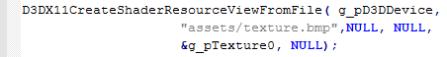

This would be best done in the InitialiseGraphics() function. Whatever you do don't do it in the RenderFrame() function!

Adding Texture Coordinates

There are several things you need to do before you can use a texture. First is changing the vertex structure to add two more floating point values that represent the u and v texture coordinates:

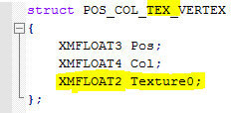

I've used the name Texture0 for these coordinates as it's possible to have more than one texture used at once, so you might need multiple sets of texture coordinates.

Of course now the vertex structure has been changed you will need to add texture coordinate data to your object vertices, here is the beginning of the new vertices array for the cube object with the coordinates added:

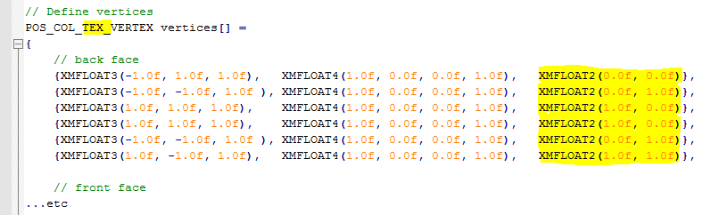

As you can see each vertex has an additional two floating point values representing the u and v texture coordinates. In this case they are all 1.0s and 0.0s as the square texture is being mapped onto a square side, in more complex objects they will usually range between 0.0 and 1.0. Note that even for a small object like the cube it can be quite time consuming correctly calculating the texture coordinates manually, in general you would use texture coordinates loaded in from a model file.

As you now have a new type of vertex, you need to change the stride to the new vertex size when you set the active vertex buffer:

Since you have now updated the vertex structure you now need to adjust the input layout so that Direct3D knows what each element of the vertex represents. This is done by adding a single line to the description array:

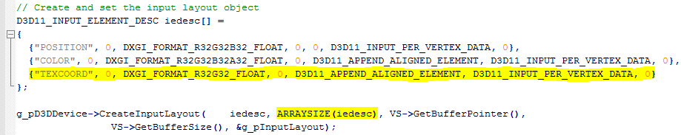


As you can see this is a much more natural looking result, and this effect is achieved using sampler states in Direct3D. A sampler state is a list of settings that the pixel shader uses in order to determine how a given texture is sampled at each point as the texture coordinates are interpolated across a triangle. This is an enormously complex subject in itself, so for now you will simply use a basic sample state that stops the 'blocky' appearance of the textures:

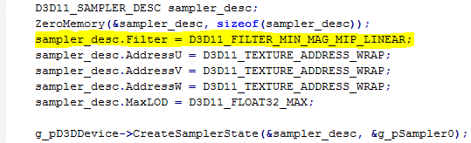

The Filter attribute is the important one here, the setting D3D11_FILTER_MIN_MAG_MIP_LINEAR is likely all you will need until for most purposes, and simply specifies that the type of filtering is linear. Linear filtering means that not only is the colour of a texel sampled, but its surrounding texels are also sampled and averaged together, resulting in the smoother rendering of the texture. The sampler state above tells the pixel shader how to correctly sample the texels of a texture in this way, the other settings are unimportant for now. The sample state creation should be in the InitialiseGraphics() function.

Setting Textures and Sample States

Once your textures and sample states have been created, you need to tell Direct3D to use them. The best place is just before an object is drawn, in RenderFrame():

The first parameter of both of these methods is the index of the texture or sampler, and the second how many are being set. Currently there is only one sampler state and one texture being used so these parameters are set to 0 and 1 accordingly. The final parameter is the address of the sampler and texture objects respectively.

Deleting Texture and Sample State Objects

When the application is exiting, delete the texture and sample state objects as you would other objects created with Direct3D:

Do this before the Context and Device are deleted, otherwise the texture and sample state objects may not be correctly deleted.

Setting the Shaders to use Textures and Sample States

The final changes needed to be made are to update the shader file in order to allow the vertex and pixel shaders to use the new texture coordinates, and the texture and sampler state.

First you need to change the vertex shader parameter list in order to reflect the addition of the u and v texture coordinates in the vertex data:

Now you need to update the vertex shader output structure to allow it to pass the texture coordinates to the pixel shader:

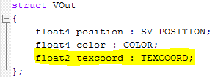

Note how both of these additions mirror the TEXCOORD semantic used when defining the input layout. The final change to the vertex shader is to pass the texture coordinates to the pixel shader:

Next you need to add a reference to the texture and the sampler state as global variables in the shader file:

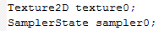

A Texture2D refers to a 2D texture. It has been named texture0 to reflect that the texture should be set at position 0 using PSSetShaderResources() as detailed before. The SamplerState sampler0 is similarly named to reflect the setting of PSSetSamplers(). Finally the pixel shader needs to be updated to receive the texture coordinates from the vertex shader, and then to use them to sample a texture:

- Check that the texture is correctly applied to your object(s).
- Create an assets folder in your project folder.
- Create a square power-of-two sided texture and fill it with an image. Save it as one of the valid image formats in the assets folder.
- Use the tutorial above to load and use the texture, updating the C++ and shader code as required.
- You will need to update the vertices array to add uv texture coordinates. If you used the cube from a previous tutorial here are the uv coordinates for that cube in the correct order:
(0.0f, 0.0f)
(0.0f, 1.0f)
(1.0f, 0.0f)
(1.0f, 0.0f)
(0.0f, 1.0f)
(1.0f, 1.0f)

(0.0f, 1.0f)
(0.0f, 0.0f)
(1.0f, 0.0f)
(0.0f, 1.0f)
(1.0f, 0.0f)
(1.0f, 1.0f)

(0.0f, 1.0f)
(0.0f, 0.0f)
(1.0f, 1.0f)
(0.0f, 0.0f)
(1.0f, 0.0f)
(1.0f, 1.0f)

(0.0f, 0.0f)
(0.0f, 1.0f)
(1.0f, 1.0f)
(1.0f, 0.0f)
(0.0f, 0.0f)
(1.0f, 1.0f)

(1.0f, 1.0f)
(1.0f, 0.0f)
(0.0f, 1.0f)
(1.0f, 0.0f)
(0.0f, 0.0f)
(0.0f, 1.0f)

(1.0f, 0.0f)
(1.0f, 1.0f)
(0.0f, 1.0f)
(0.0f, 0.0f)
(1.0f, 0.0f)
(0.0f, 1.0f)

If you have used your own object, or significantly altered the cube, you will have to work out the texture coordinates for yourself.
- Check that the texture is correctly applied to your object(s).

Exercise 02 - Using Textures to Display Text

There is no in-built way to display text on screen in DirectX11, so this needs to be done using textures. Because of this I have written a basic text display class that you can use. It is limited in functionality, so you may want to add features of your own (see Additional Exercises) or write your own class:

- Create a new project based on your Tutorial 08 Exercise 01 project, renaming it in the correct way.
- From the provided zip file copy text2d.cpp, text2D.h, text2D_shaders.hlsl to the project folder. Add these files to the project solution.
- Copy Font1.bmp to the assets folder.
- In main.cpp include the header file.
- Add a global:
- At end of InitialiseD3D() add:
- At end of RenderFrame(), just before Present() add:
- To display text you simply need to call the AddText() method:
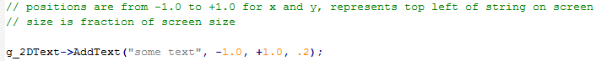
This method can be called multiple times per frame in order to draw text in different places, and you can pass an std::string to the method in order to have dynamic text. Be aware that all the strings are deleted once drawn each frame, so you need to call the AddText()method every frame for a given string in order for it to be constantly displayed.
- The Text2D RenderText() method changes texture, sampler state, vertex type, vertex buffer input layout and shaders. Because of this you may need to add code to reset these before you draw your object(s) in RenderFrame(). Here is a list of all the methods that now need to be called every frame:

g_pImmediateContext->IASetVertexBuffers();

g_pImmediateContext->IASetPrimitiveTopology();

g_pImmediateContext->VSSetConstantBuffers();

g_pImmediateContext->PSSetSamplers();

g_pImmediateContext->PSSetShaderResources();

g_pImmediateContext->VSSetShader();

g_pImmediateContext->PSSetShader();

g_pImmediateContext->IASetInputLayout();

If you find that your object(s) have disappeared once the text code has been added please check carefully that all the above are being correctly called each frame.
- Don't forget to delete the Text2D object before the program exits.

